MYSQL WORKBENCH INSTALLATION

1. Please download the MySQL installer from : [MySQL :: Download MySQL Installer](https://dev.mysql.com/downloads/installer/)

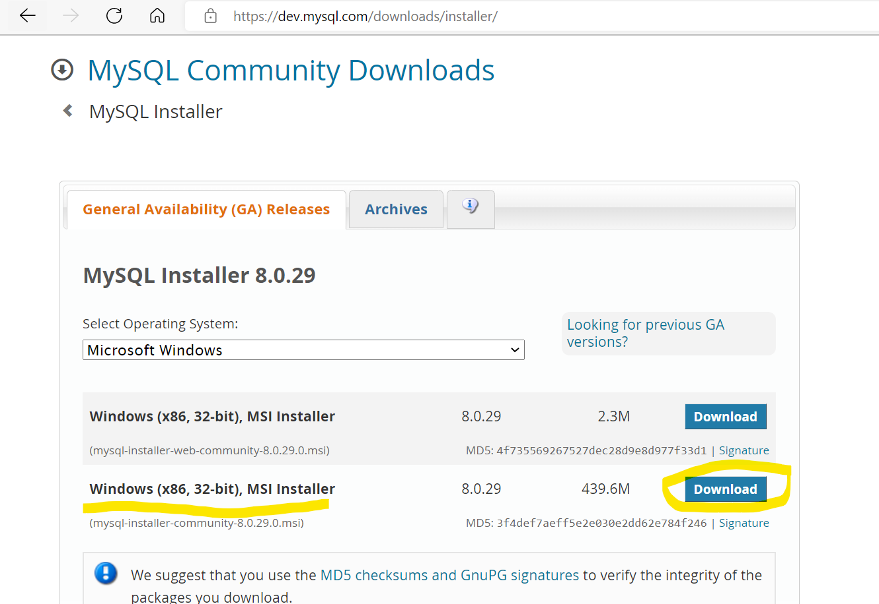

1. Post clicking Download option, please click on **No thanks, just start my download ,** It will start downloading the installation file

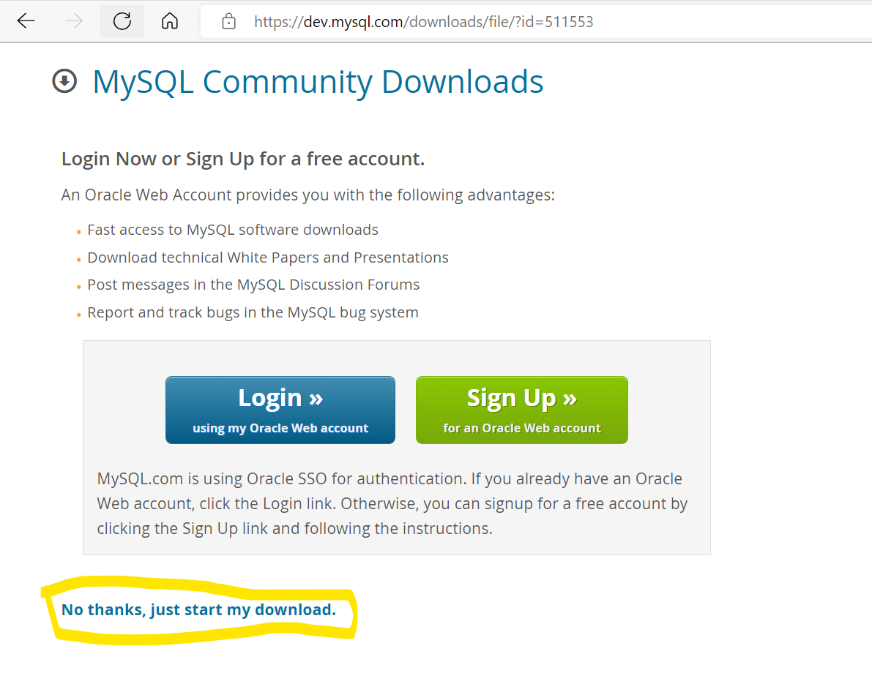

1. Post download completion, Please double click on the downloaded file present at Downloads: **mysql-installer-community-8.0.29.0**

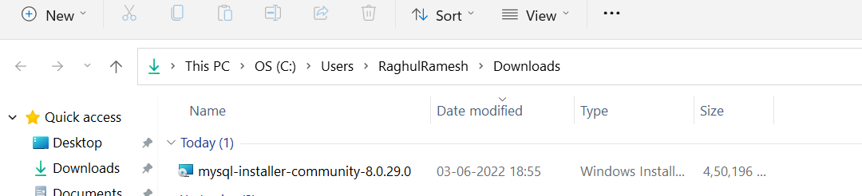

We will see the pop up asking **DO YOU WANT TO ALLOW TO MAKE THE CHANGE ,** Please click on YES all the times

1. Please click on **Custom** option and click on **Next**

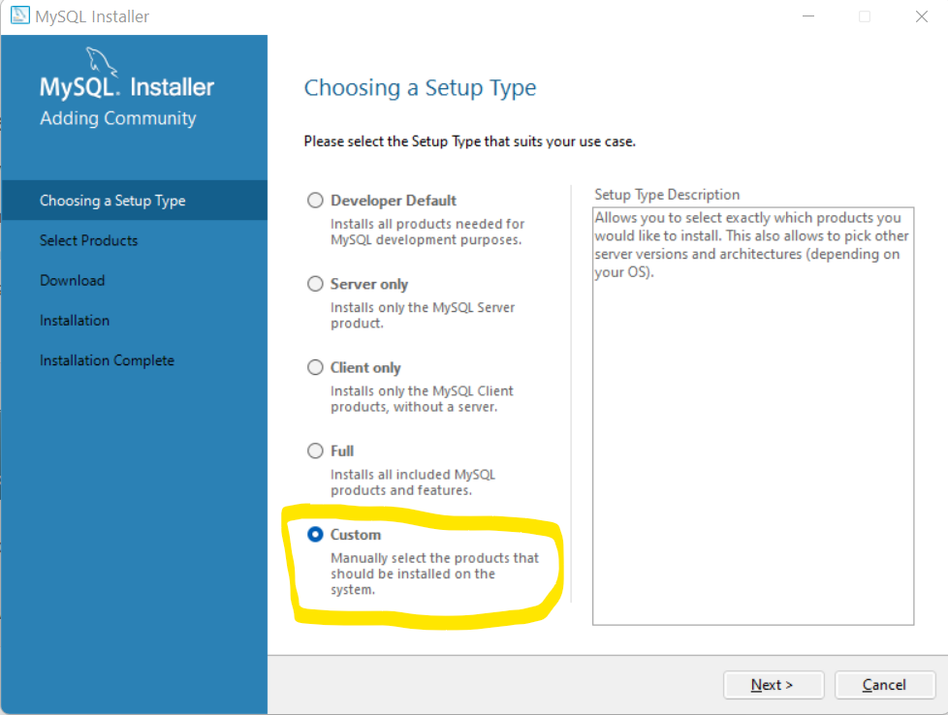

1. From the following option, Please click on + option before MySQL Server and again click on + option MYSQL Server and please click on + presents before MySQL Server 8.0 and we will see the option MYSQL Server 8.0.29 – X64 , Please select on MYSQL Server 8.0.29 – X64 and click on 🡪 option to move on right side as show below in the screenshot

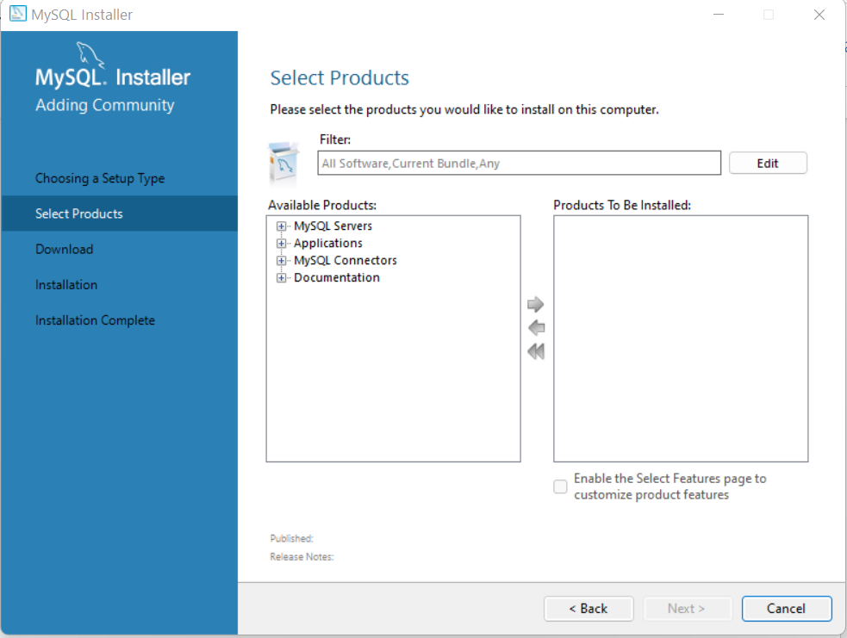

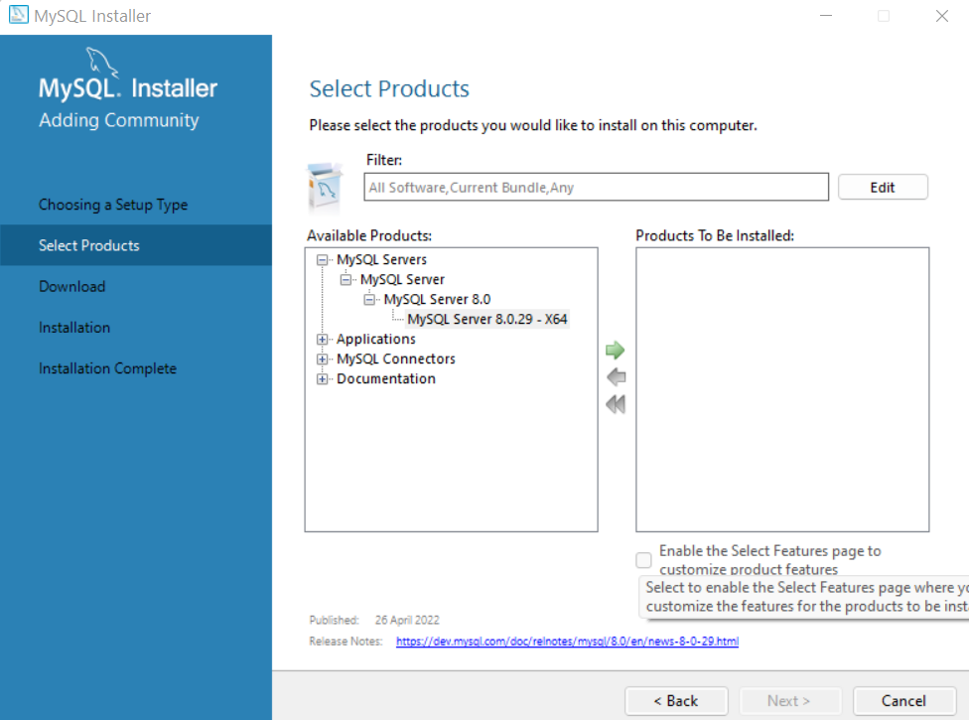

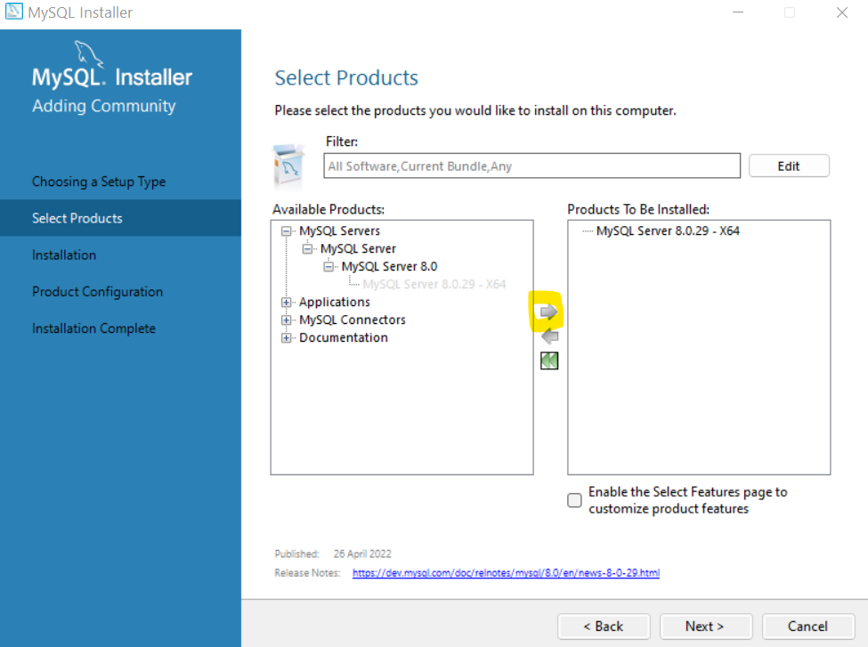

**We need to perform the same action for Applications as follows and need to move the following to right side**

**MYSQL Workbench 8.0.29**

**MYSQL Shell 8.0.29 – X64**

**MYSQL Router 8.0.29 – X 64**

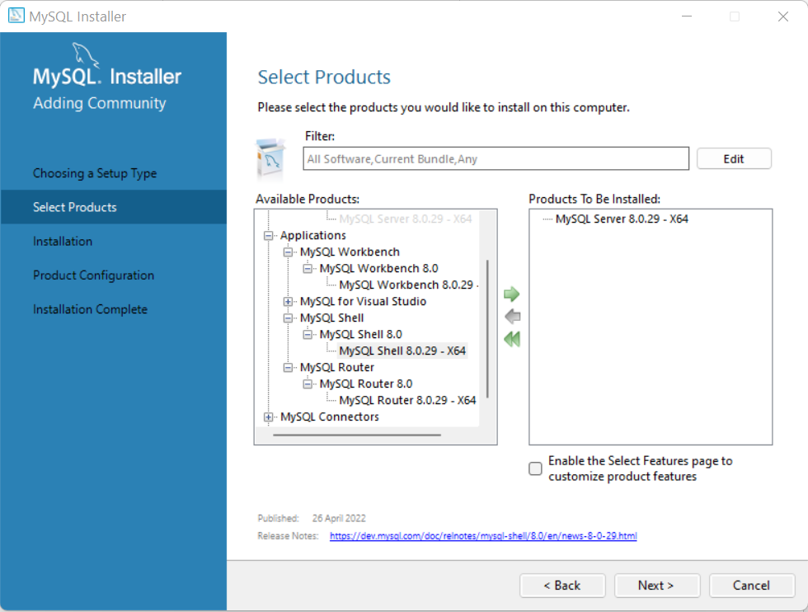

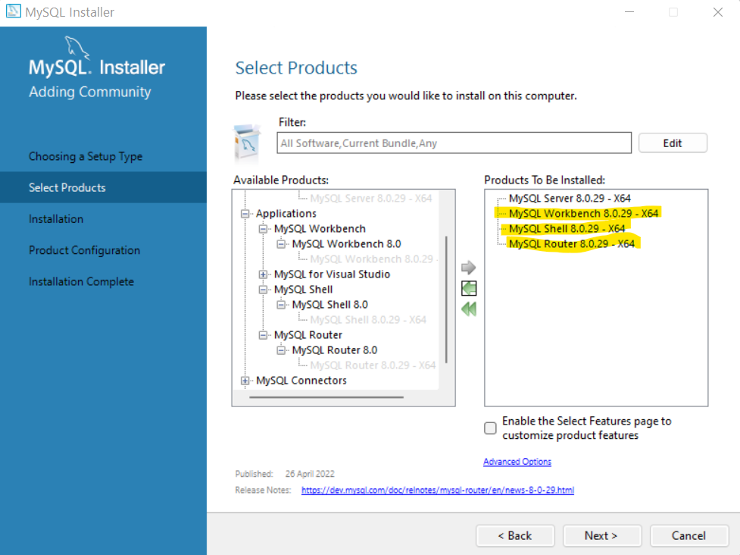

Please perform the similar option clicking on MYSQL Connectors🡪Connector/ODBC

We will see the following options

Connectors/ODBC 8.0.29 -> X64

Connectors/ODBC 8.0.29 -> X86

Please click on “ Connectors/ODBC 8.0.29 -> X64” and move it to right side as follows

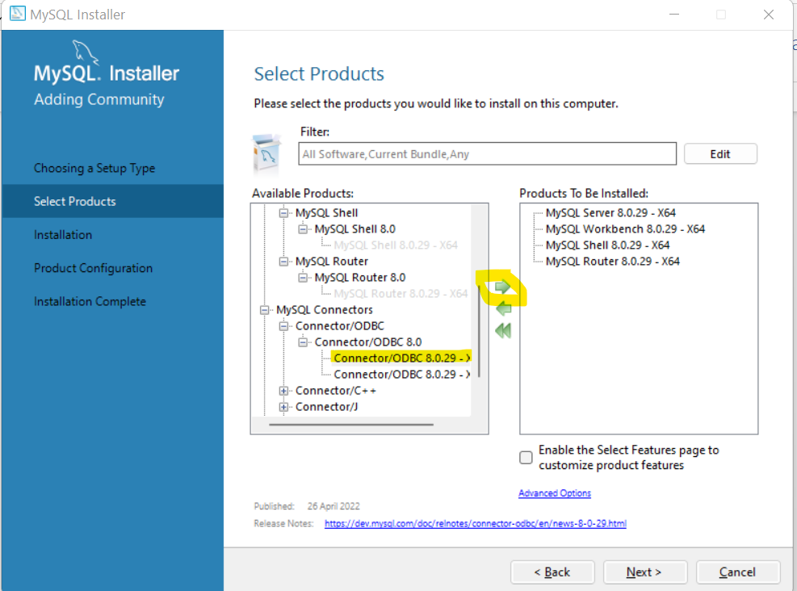

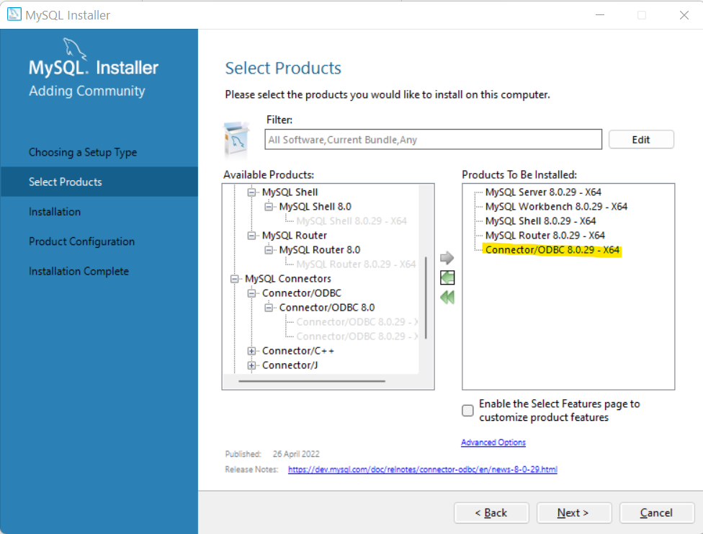

1. And click on the check box present before “Enable Select Features page to customize product features” and click on Next

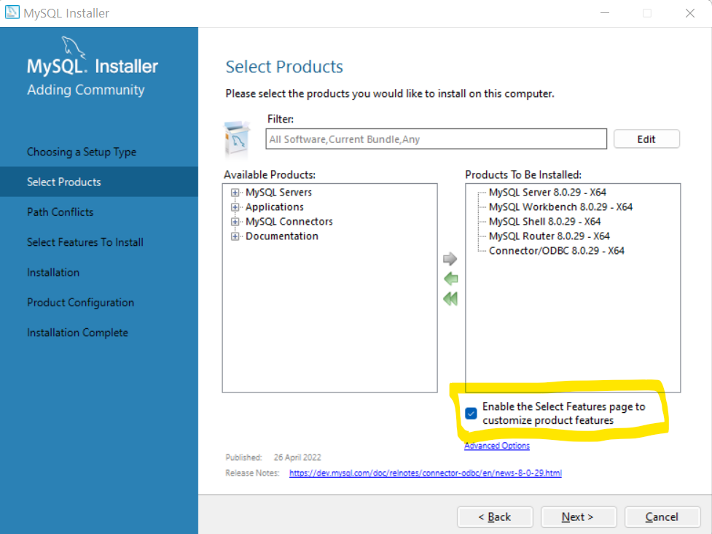

1. Please click on Next from the following screen

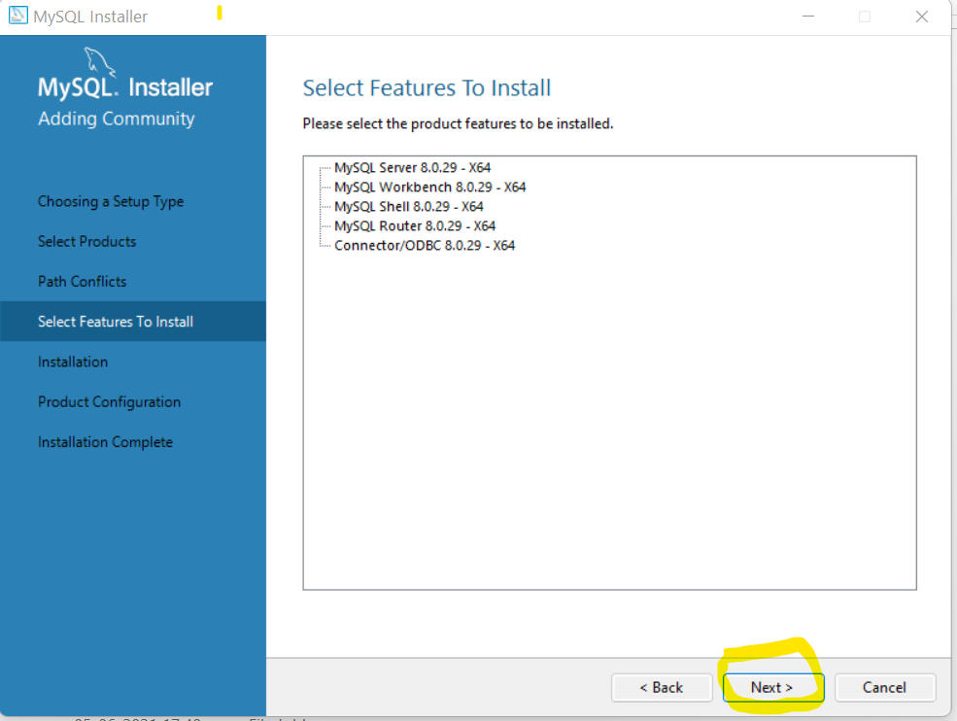

1. Please click on Execute from the following option

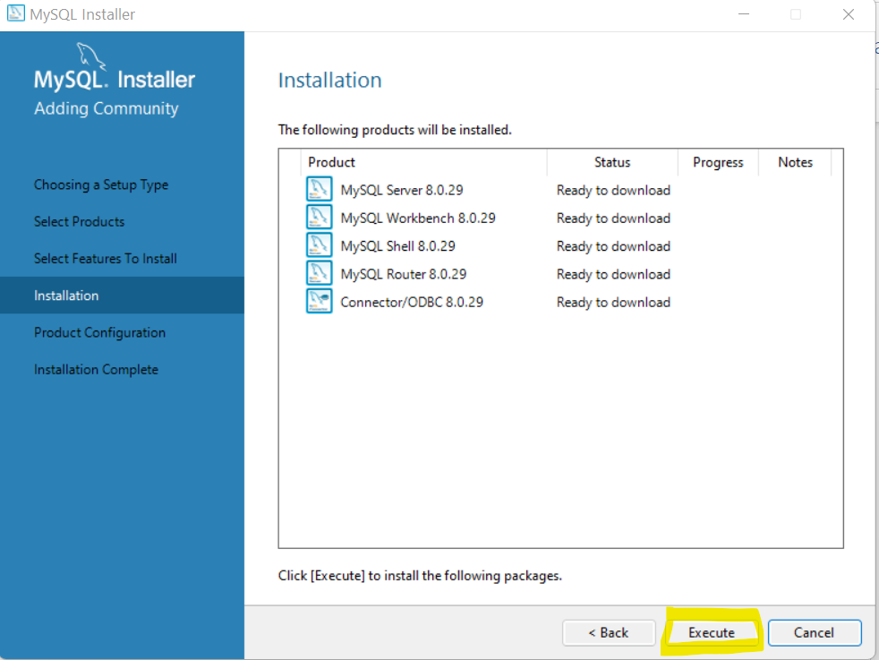

It will start downloading all the files, Post download completes click on next

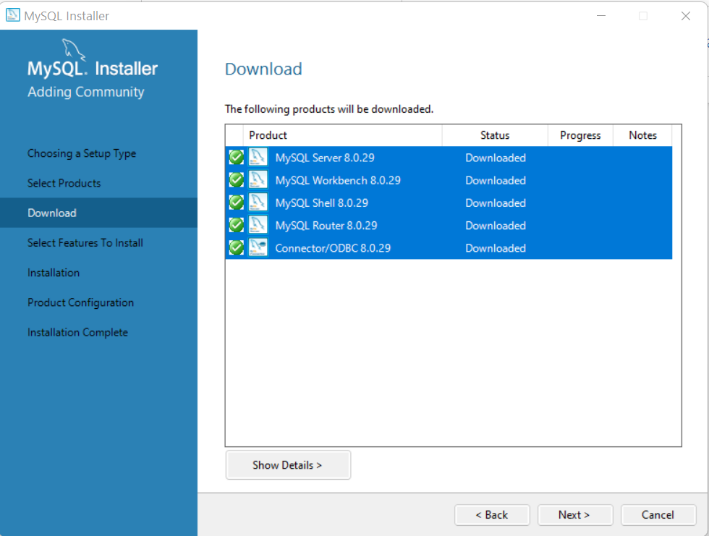

Please click on Next

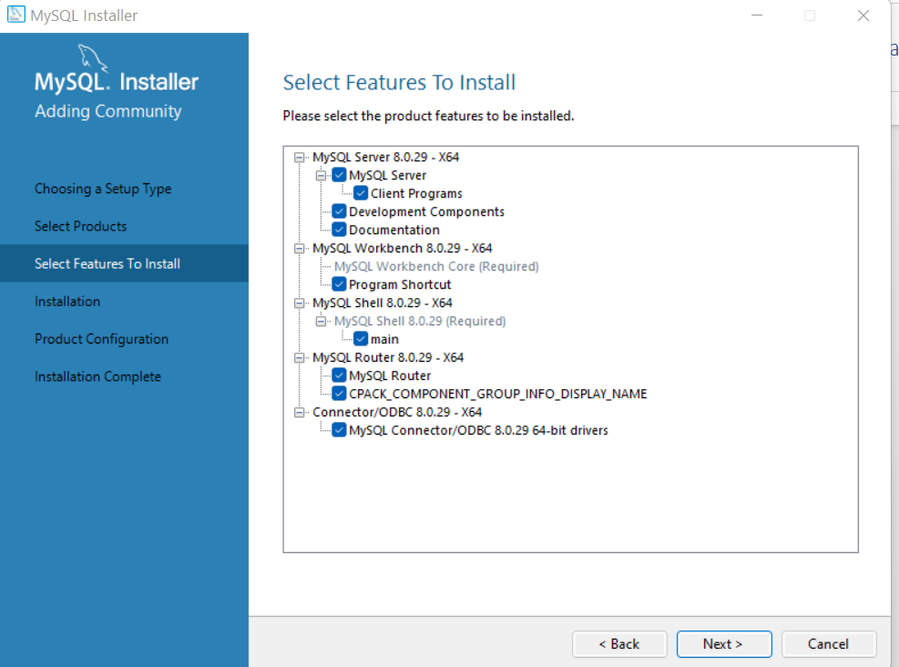

Click on Execute from following

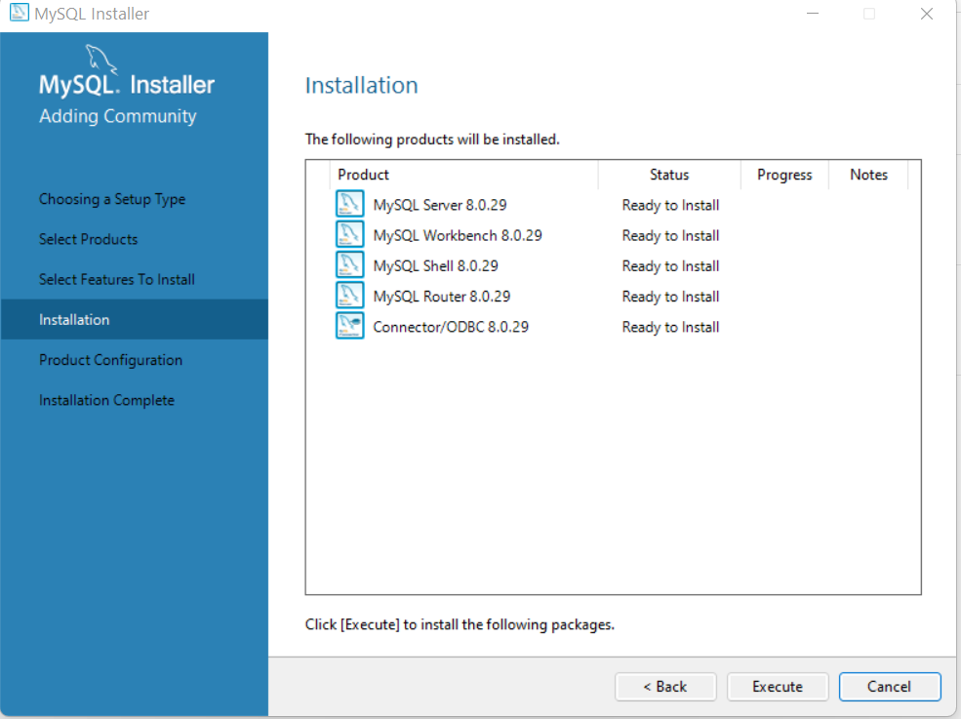

This will take **sometimes** because it has to install the products (Particularly the MySQL Shell 8.0.29 takes quite longer time)

Once the installation completes then we will see the following screen

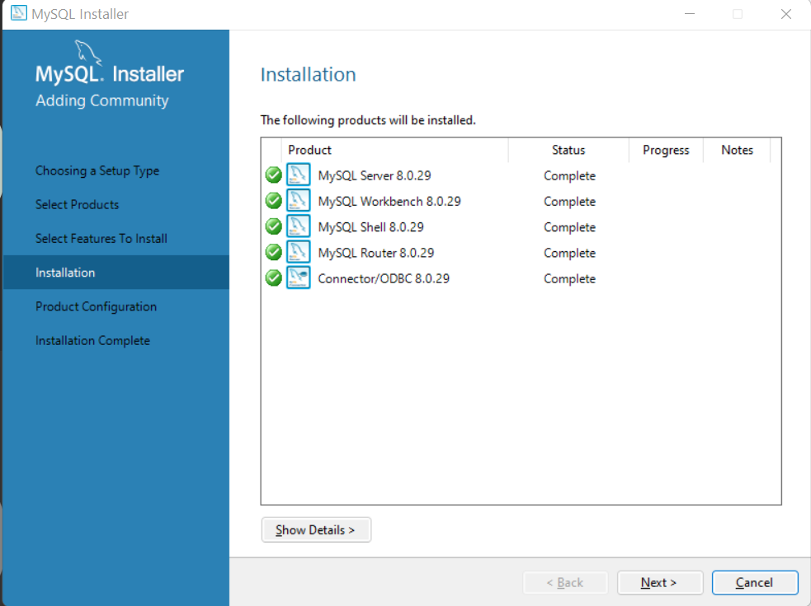

Please click on Next here and click on Next again from the following

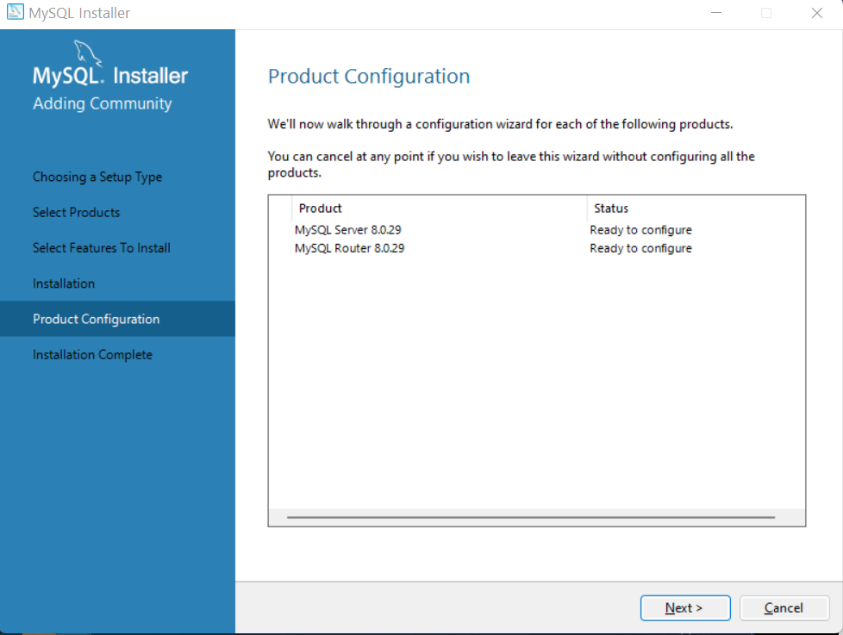

Please click on Next

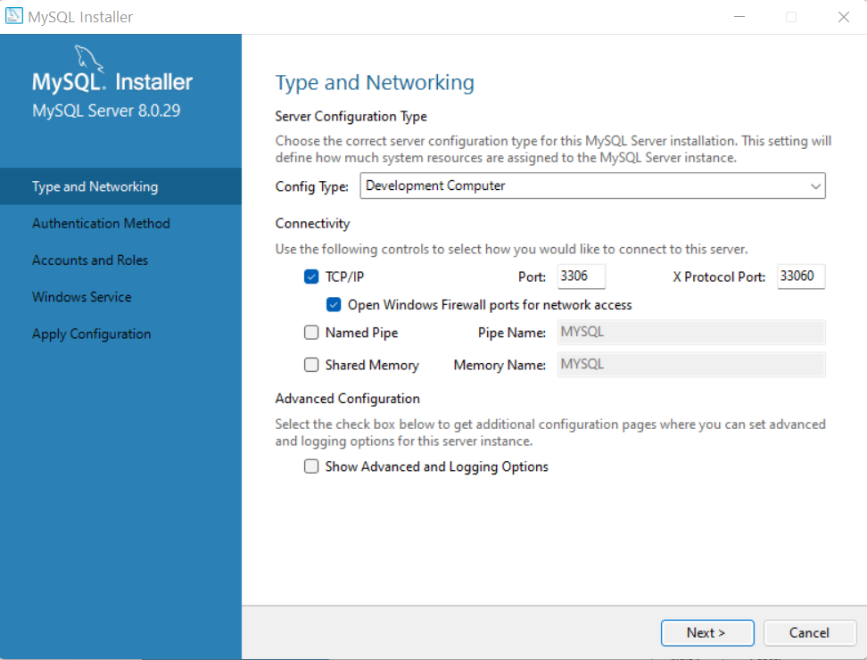

Please click on Next

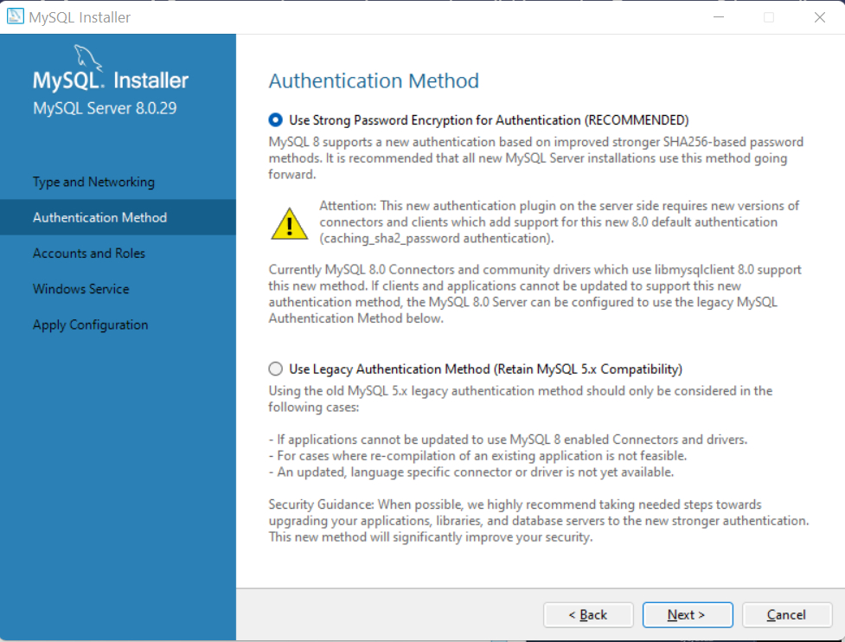

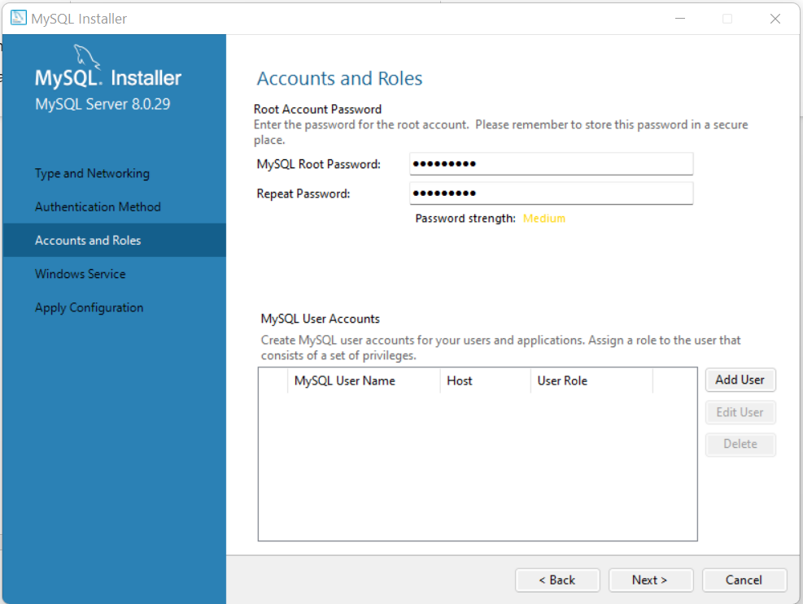

Enter a password “Root@123” twice and click on Next

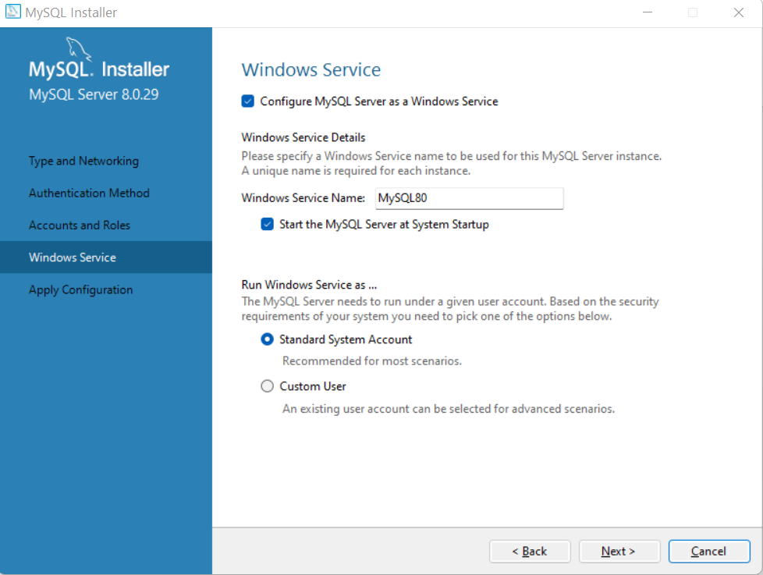

Please click on Next

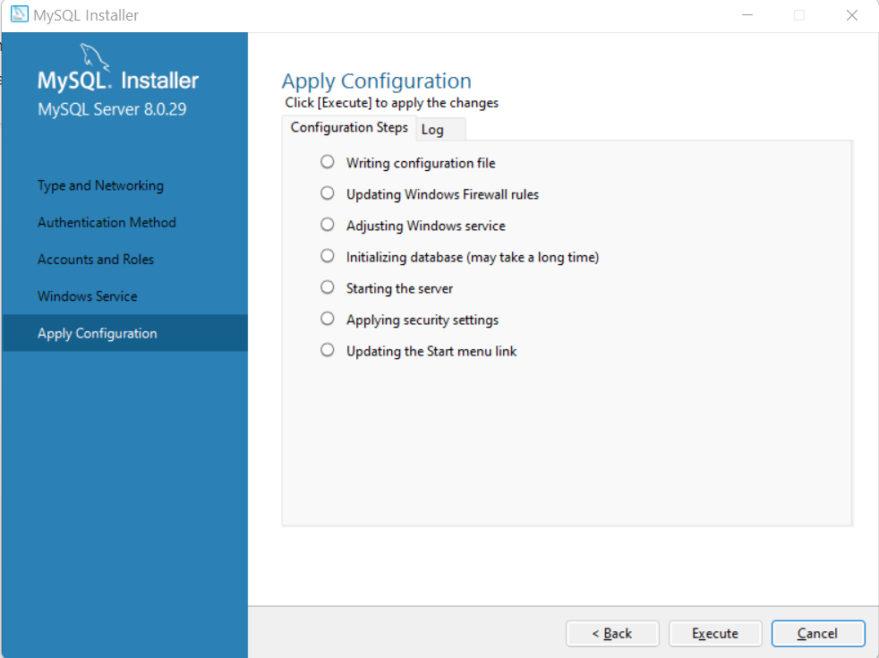

Please click on Execute

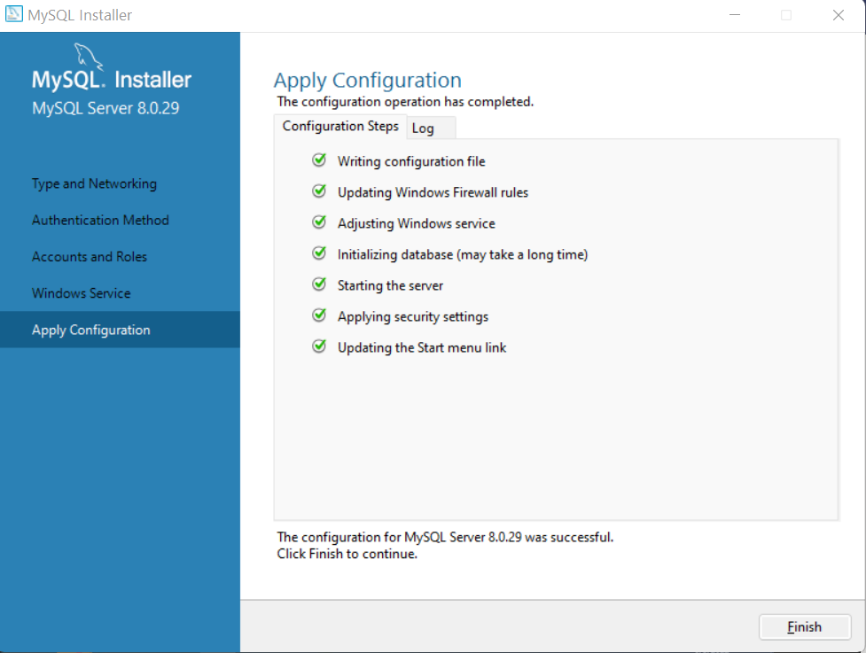

Please click on Finish

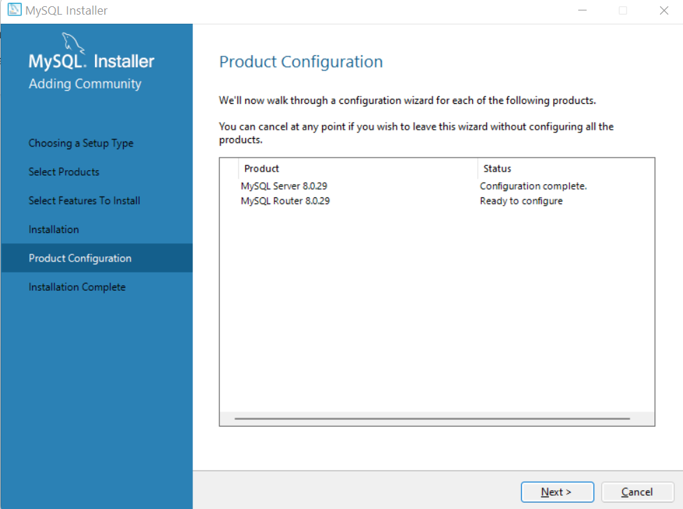

Please click on Next

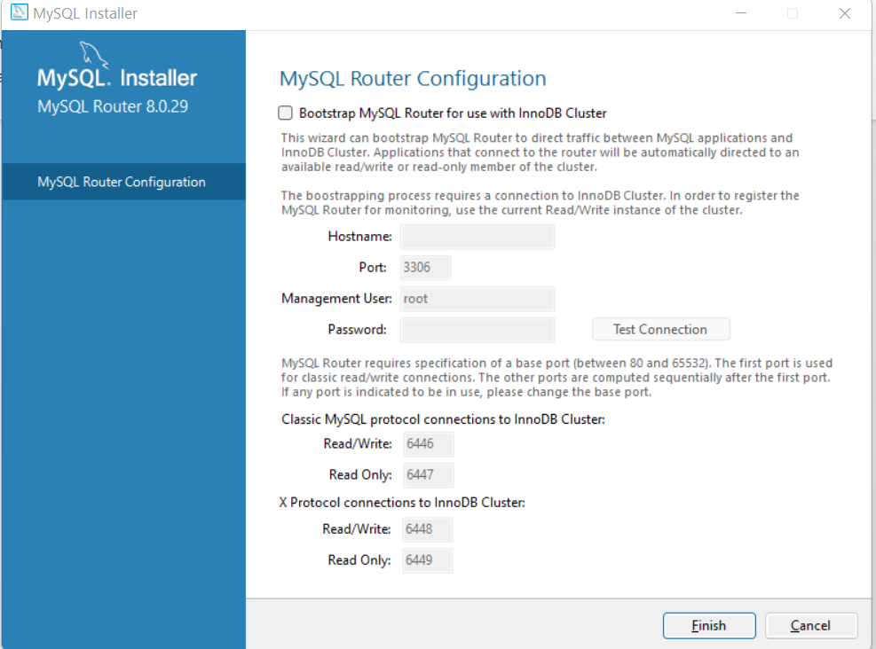

Please click on Finish

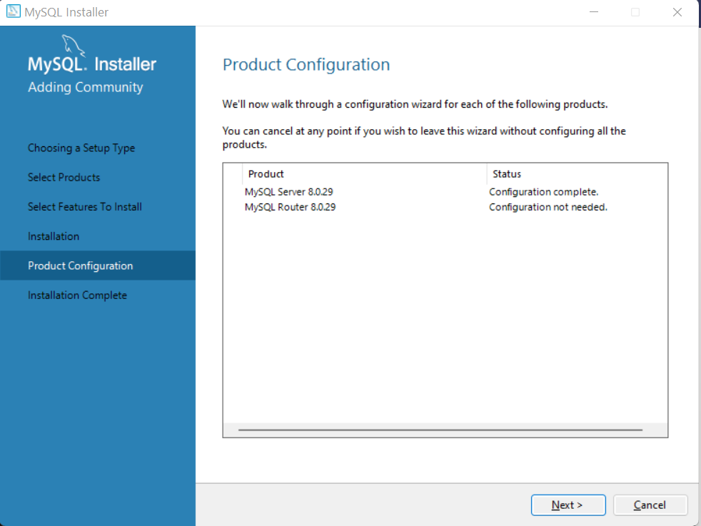

Please click on Next

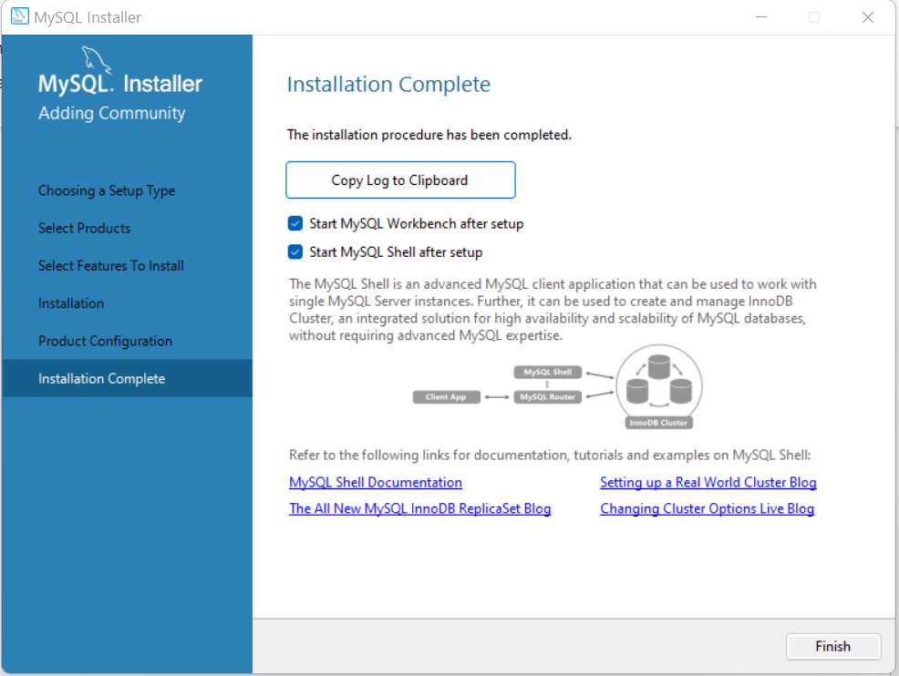

Please click on Finish

WE HAVE INSTALLED SUCCESSFULLY.

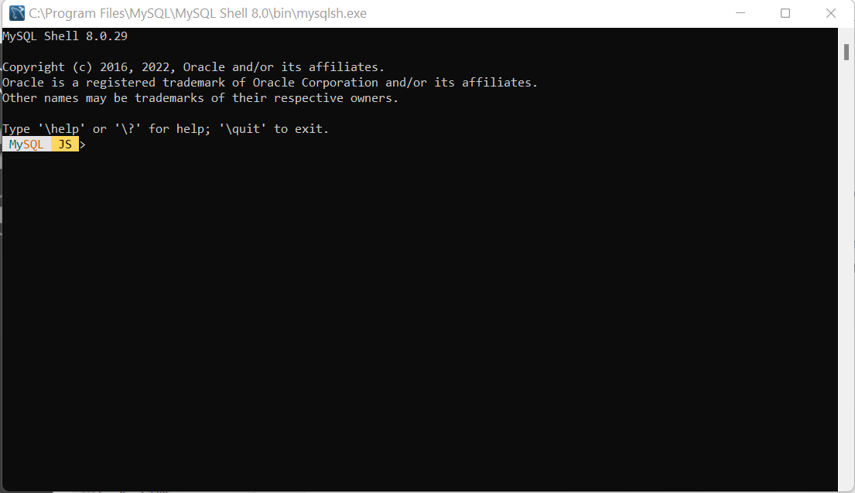

Please minimize this window and got to MySQL WORKBENCH

Click on Database 🡪 Connect to Databases 🡪

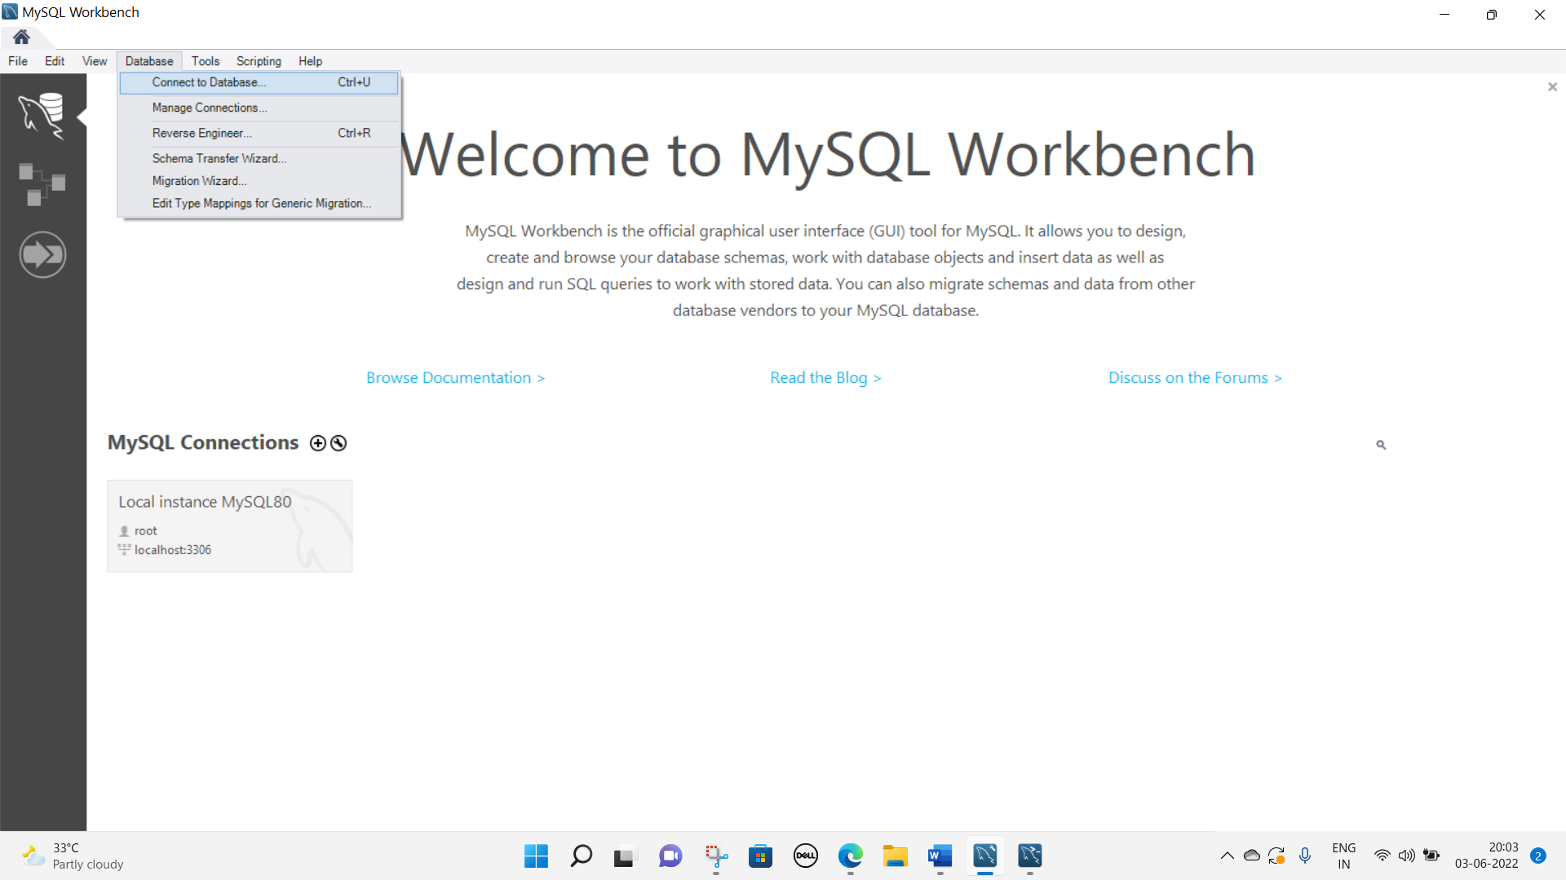

In Stored Connection : Local Instance MySQL80

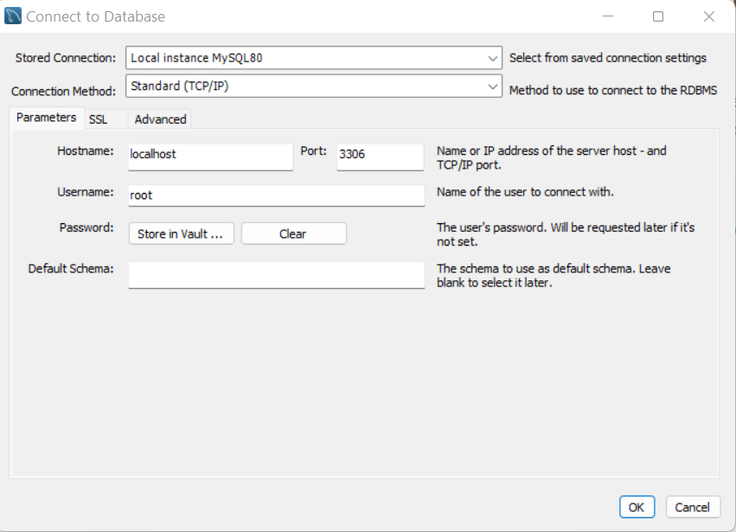

Please click on OK here

Please ignore the warning

